These are some strategies to help your children learn their spellings at home. They could try:

1. Look, say, cover, write, check.
   1. Look – Look at the word and if there are any parts of it that are particularly challenging, give them extra attention.
   2. Say the word as you look at it and, if you need to, pronounce it in ways that will make it more memorable, e.g. Wed-nes-day.
   3. Cover – Cover the word so you can no longer see it.
   4. Write – Write the word from memory, saying it as you do.
   5. Check – Have you spelled it correctly? Yes? Great! Write it again lots of times. No? That’s fine, start at the first step again to give it another go. Alternatively, try another strategy.
2. Trace, copy and replicate.
   1. Write the word on a piece of paper. Make sure it’s big enough to trace and definitely ensure that it’s spelt correctly!
   2. Trace over the word and then write it next to the word you have traced. After that, flip the paper over and write it on the opposite side. Remember to say the word every time you write it.
   3. Check all of your spellings and make sure that you have spelt them correctly. If they are, have a go at restarting the process but this time, add an additional word.
   4. Keep adding words on until you have done all of the spellings you want to, then just write them without the tracing.
3. Quickwrite!
   1. Write the words you are trying to learn as many times as you can in a set time, e.g. 30 seconds. How many can you do? If you are doing this, ensure that the first time you write the word is correct.
4. Draw around the word to show the shape.

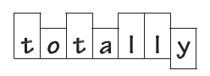

* 1. Make sure you have made ascenders ascend and descenders descend, or you won’t see them!

1. Draw an image around the word.

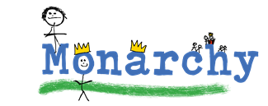

* 1. Draw images around the word that will make it more memorable. This method works better for those particularly tricky words that the other strategies aren’t working for.

1. Pyramid words.

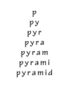

* 1. This method requires you to think of every letter individually, so will help where the word can be sounded out.

1. Hangman.
   1. Make spelling fun and have a game of hangman. Use this to reinforce the spellings once you have used other strategies.