**Ancient Greeks**

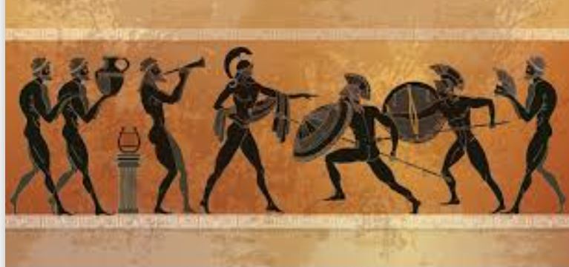

**Design Technology**

Food Technology.

What is traditional Greek food?

Learn about and try different foods and follow a recipe using a range of kitchen tools safely and accurately.

**Science**

Human Development:

Changes which occur from Babies to Adulthood.

**A Caring Community**

We will consider our relationships with others in the school and wider community and further develop our ability to work productively together. We will also consider what impact the Greeks legacy has on our lives today.

**Locality & Environment**

Local architecture + Greek Influence e.g. Crown Spa, Library, Station

**Music**

Mood – exploring sound sources

**Art**

Clay – studying the style and design of Greek pots and plates, planning and creating our own pots.

**Computing**

Creating media – Introduction to vector graphics

**History**

* Ancient Greek life & achievements & their influence on the wider world

- Daily Life: Homes, Clothes, Men & Women, Food, Schooling, Gods

- Greek Legacy: Language, Democracy, Theatre, Olympics, Architecture

**Wheatcroft Community Primary School**

**Year 5 Ancient Greeks**

**Curriculum enhancements**: Greek Day



**Maths**

Fractions

Decimals & percentages

Perimeter and Area

Statistics

**English (Class Reader)**

**Reading:** The Odyssey, Who let the Gods out? Ancient Greek Myths & Legends, Non-fiction texts.

**Writing:** Speeches (proclamation, persuasive, soliloquy), diary entry, dialogue, missing scene, postcard, advertisement

Main outcome: Epic adventure story

**French**

 Le petit déjeuner

**PE**

Gymnastics & Cricket

**RE** What would Jesus do?

Can we live the values of Jesus in the 21st Century?

**PSHE**

Healthy Me

**Geography**

Atlases & Maps:

Where is Greece? Modern day climate, features etc.